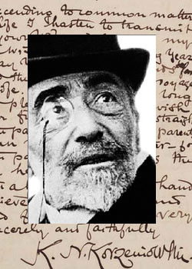
The Joseph Conrad Society (UK)

45th Annual International Conference
5–7 July 2018

Writtle University College,
Lordship Road, Chelmsford,
Essex CM1 3RR

President: Laurence Davies

Chair: Robert Hampson

Conference Registration Fee

A registration fee of £80 covers all sessions (£40 for students). A payment of £25 (£15 for students) covers attendance for a single day or part thereof.

Meals

Please note that the cost of meals does not include alcohol. The Society will part-subsidise meals for students.

Membership

Conference participants who are not already members of the Society are asked to take out a year’s membership. The rate is £35 (£20 for students).

The conference programme will be posted at www.josephconradsociety.org.

Accommodation

Attendees are invited to make their own accommodation arrangements. Writtle University College has accommodation (bed and breakfast) at a cost of £38 per night. To take up this convenient offer, please contact Jo Hasnip at Writtle University College directly: jo.hasnip@writtle.ac.uk

Due Date

Please send your completed Booking Form to the Conference Secretary, Kim Salmons, by 20 June 2018: kim.salmons@stmarys.ac.uk For payment details, please see the Booking Form ‒ or indicate that you will pay on arrival at the conference.

Booking Form: 2018 Conference

Name:
Address:

E-mail:

All payments are to be made in pounds sterling. Foreign currency will not be accepted. Please make cheques payable to: The Joseph Conrad Society (UK). For details of how to pay by direct credit, please see the Society website: www.josephconradsociety.org under ‘Becoming a Member’, see ‘Membership Dues Form’.

Conference
Total cost (meals, barge trip, subscription to The Conradian)
Regular subscriber: £233
Student: £144

OR Itemized breakdown

Registration Fee

All sessions: £80 regular (£40 for students)
Single day or part thereof: £25 (£15 for students)

Meals (Please indicate if vegetarian or other special dietary requirement)

Thursday 5 July: lunch £8.50 (£6 students)
Friday 6 July: morning coffee/tea £1.85 (free for students)
Friday 6 July: lunch £8.50 (£6 students)
Friday 6 July: afternoon tea £1.85 (free for students)
Friday 6 July: Gala Dinner £35.00 (£25 students)
Saturday 7 July: brunch £2.30 (£2 students)

Outings
Thursday 5 July Barge Trip (including dinner): £60 (£45 students)

Membership/Subscription The Conradian £35 regular; £20 students

Total

The Joseph Conrad Society (UK) c/o POSK,
238-246 King Street, London W6 0RF. United Kingdom

