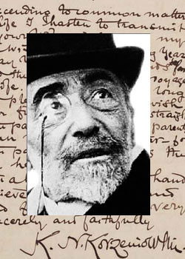
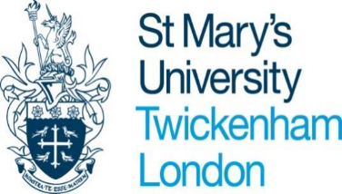

St Mary’s University Joseph Conrad Lecture Series

in collaboration with the Joseph Conrad Society (UK) presents

‘Reading Conrad in the Modern World’

St Mary’s University and the Joseph Conrad Society (UK) presented a series of lectures by esteemed Conradians on ‘Reading Conrad in the Modern World’. The lectures (delivered via Zoom) were held on the first Saturday of each month until July, and comprised a 50 minute lecture, a 10 minute break, and 30 minutes of interactive discussion

For more information and access to previous presentations contact Kim Salmons: kim.salmons@stmarys.ac.uk

Conrad Lecture Series ‘Reading Conrad in a Modern World’

Prof. Robert Hampson, Royal Holloway, University of London  ‘Conrad and Africa’. | Saturday 5th February 2pm GMT
Prof. Yael Levin, the Hebrew University of Jerusalem  ‘Becoming Planetary: the emergence of alterity in Nostromo’. | Saturday 5th March 2pm GMT
Prof. Linda Dryden, Edinburgh Napier University  ‘Conrad: Portrait of the Artist in the Modern World’. | Saturday 2nd April 2pm GMT
Prof. William Atkinson, Appalachian State University  'Conrad and Ukraine'. | Saturday 7th May 2pm GMT
Prof. Tania Zulli, Università degli studi G. d’Annunzio  ‘Conrad and Transnationalism: Fiction, Visual Arts and the Modern World’. | Saturday 4th June 2pm GMT
Prof. Laurence Davies, Kings College, University of London | Saturday 2nd July 2pm GMT

