THE MARIA CURIE-SKŁODOWSKA UNIVERSITY –
COLUMBIA UNIVERSITY PRESS CONRAD PROJECT

CONRAD’S FOOTPRINTS
SEVENTH INTERNATIONAL JOSEPH CONRAD CONFERENCE
MARIA CURIE-SKŁODOWSKA UNIVERSITY, LUBLIN, POLAND
20-24 June 2022

CIRCULAR II
CALL FOR ABSTRACTS

I. The Honorary Patronage and Dedication:
We are very happy and honoured to announce that the conference will be held under the Honorary Patronage of The European Parliament.
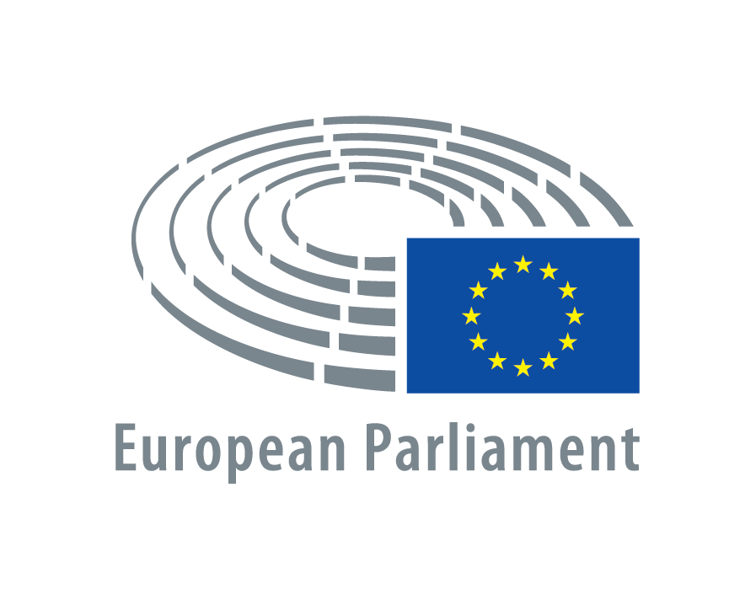

The conference is organized In Honour of Wiesław Krajka, professor emeritus of Maria Curie-Skłodowska University in Lublin, the editor of Conrad: Eastern and Western Perspectives, to commemorate publication of 30 volumes of this series and 50 years of His academic work.

II. Abstracts:
We plan to publish a booklet of abstracts of papers prior to the conference and distribute it among participants on registration. The participants presenting papers are requested to submit their abstracts by November 15, 2021 at the latest. The text, in English, should be no longer than 250 words. An abstract should contain no references. The heading of an abstract should contain its author’s name and surname, University, town and country, and the title of the paper. Please send your abstract as an e-mail attachment in Word to the conference e-mail address (conradconference@poczta.umcs.lublin.pl).

III. Scholarly program:
The scholarly proceedings will be composed of papers on various aspects of Joseph Conrad’s life and works, and related themes (Conrad’s Polish and East-Central European aspects and contexts will be one of the foci of the conference). Apart from inaugural and concluding plenary lectures, all papers will be delivered in sections running in parallel sessions. Kinds of sessions and their number will be decided upon and announced when we fix the program of the conference. Each paper presentation should not exceed 35 minutes plus 10 minutes for discussion. English will be the official language of the conference. Members of the Organizing Committee may help with reading a paper or translating discussion upon it for those colleagues who do not feel comfortable enough in English – upon their request.

IV. Publication of the conference papers:
Select papers from the conference will appear in two peer-reviewed volumes of the series Conrad: Eastern and Western Perspectives published by Maria Curie-Skłodowska University Press Lublin and Columbia University Press New York (as a follow-up to the volumes of this series published so far). Presentation of a paper at the conference does not automatically guarantee its publication in the post-conference volumes. A paper submitted for publication consideration should be sent as an e-mail attachment to the conference e-mail address (conradconference@poczta.umcs.lublin.pl) by 31 August 2022 at the latest (there is no length limit fixed for papers submitted for publication). Then, they will be subjected to regular peer-review process. The text, double-spaced, should be written in Word and should follow the MLA Style Sheet.

V. Study tour:
From 24 to 29 June, following the conference, we plan a study tour of Conrad’s footprints in Poland (taking in Lublin, Cracow, Zakopane and Warsaw).

VI. Financial principles of the conference:
- Participants’ travel costs to Lublin and back are to be met by them.
- All individual costs of participation in the conference (especially accommodation and meals) are to be covered by participants themselves.
- There is no conference fee. All general costs of the conference are met by Maria Curie-Skłodowska University (the organizer and the sponsor of the conference). They include mainly the cost of hiring rooms for holding sessions, printing the booklet of abstracts and the program of the conference, transportation of participants during the conference.
- All costs of participation in the study tour of “Conrad’s footprints” are to be met by its participants. A tour fee will be fixed to cover the cost of transportation by coach on the tour.
- Conference participants are kindly invited and encouraged to contribute financially to the organizing committee during the conference to help it cover the general costs of the conference.

VIII. Communication and next circulars:
Information about the conference can be obtained from the following website:
www.conradcentre.umcs.eu
The conference e-mail address is: conradconference@poczta.umcs.lublin.pl
Circular III will be sent in January 2022: it will provide mainly an outline of the program of the conference and the proposed study tour (24-29 June, 2022), registration forms, recommended accommodations for the conference and information about possible ways of reaching Lublin by plane, train and bus.
Circular IV (final) will be issued in June 2022: it will provide the program of the conference and indispensable final details concerning its organization.

Lublin, December 2020 Anne Mydla
Conference Secretary
THE MARIA CURIE-SKŁODOWSKA UNIVERSITY –
COLUMBIA UNIVERSITY PRESS CONRAD PROJECT

CALL FOR PAPERS

CONRAD'S POLISH FOOTPRINTS.
SEVENTH INTERNATIONAL JOSEPH CONRAD CONFERENCE
AT MARIA CURIE-SKŁODOWSKA UNIVERSITY, LUBLIN, POLAND

Date of the conference: 20–24 June, 2022
Date of the study tour of Conrad's Polish footprints: 24-29 June, 2022
Place: Maria Curie-Skłodowska University, Lublin, Poland
Address: Institute of Modern Languages and Literatures, Maria Curie-
-Skłodowska University Pl. Marii Curie-Skłodowskiej 4a, 20-031 Lublin
Poland
e-mail: conradconference@poczta.umcs.lublin.pl
web: www.conradcentre.umcs.eu

CIRCULAR I

The Centre for Conrad Studies, Institute of Modern Languages and Literatures, Maria Curie-Skłodowska University, Lublin, Poland, will have the honour and pleasure of hosting its Seventh International Joseph Conrad Conference between June 20 and 24, 2022. Conradians and students and lovers of Conrad are heartily invited to attend.
The scholarly proceedings (in English) will consist of papers on various aspects of Joseph Conrad's life and works, and related themes, including Conrad’s Polish and East-Central European contexts. Select papers from the conference will appear in two peer-reviewed volumes of the series Conrad: Eastern and Western Perspectives, published by Maria Curie-Skłodowska University Lublin and Columbia University Press New York.
From 24 to 29 June, following the conference, we plan a study tour of Conrad's Polish footprints, taking in Lublin, Cracow, Zakopane, and Warsaw.
Please send a declaration of your intended participation in the conference (either with or without a contributed paper) to the conference e-mail address. If you know any academics who might have an interest in our conference, please encourage them to respond.

Lublin, December 2020 Anne Mydla
Conference Secretary

