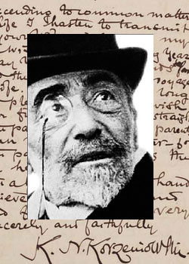
The Joseph Conrad Society (UK)

41st Annual International Conference
London | 2-4 July 2015

POSK, 238-246 King Street, Hammersmith: 2-3 July
University Women’s Club, 2 Audley Square, Mayfair: 4 July

President: Laurence Davies

Chair: Robert Hampson

Conference Registration Fee

A registration fee of £60 covers all sessions (£30 for students). A payment of £20 (£10 for students) covers attendance for a single day or part thereof.

Meals

Evening meals on Thursday and Saturday, and Saturday lunch, are bookable in advance. Please note that the cost of meals does not include alcohol, which can be purchased separately. For other meals, we will use local cafés and pubs. The Society will part-subsidise the Saturday dinner for students.

Membership

Conference participants who are not already members of the Society are asked to take out a year’s membership. The rate is £35 (£20 for students).

The conference programme will be posted at www.josephconradsociety.org.

Accommodation

Participants make their own accommodation arrangements. For assistance, please consult the ‘Annual Conference’ page on the Society’s website – www.josephconradsociety.org.

Due Date

Please send your completed Booking Form to the Secretary, Hugh Epstein, by 26 June 2015: hughepstein@hotmail.co.uk For payment details, please see the Booking Form ‒ or indicate that you will pay on arrival at the conference.
Booking Form: 2015 Conference

Name:
Address:

E-mail:

All payments are to be made in pounds sterling. Foreign currency will not be accepted. Please make cheques payable to: The Joseph Conrad Society. For details of how to pay by direct credit, please see the Society website: www.josephconradsociety.org under ‘Becoming a Member’ , see ‘Membership Dues Form’

Total registration, including subscription and all meals
Regular subscriber: £170
Student: £110

OR Itemized breakdown

Registration Fee

All sessions: £60 regular (£30 for students)
Single day or part thereof: £20 (£10 for students)
Meals (Please indicate if vegetarian or other special dietary requirement)

Meal at POSK
Thursday 2 July, Dinner: £18

Meals at the University Women’s Club
Saturday 4 July, Lunch, coffee, tea: £22
Saturday 4 July, Dinner: £35 (£20 for students)

Membership £35 regular | £20 students

Total enclosed

The Joseph Conrad Society (UK) c/o POSK,
238-246 King Street, London W6 0RF. United Kingdom

